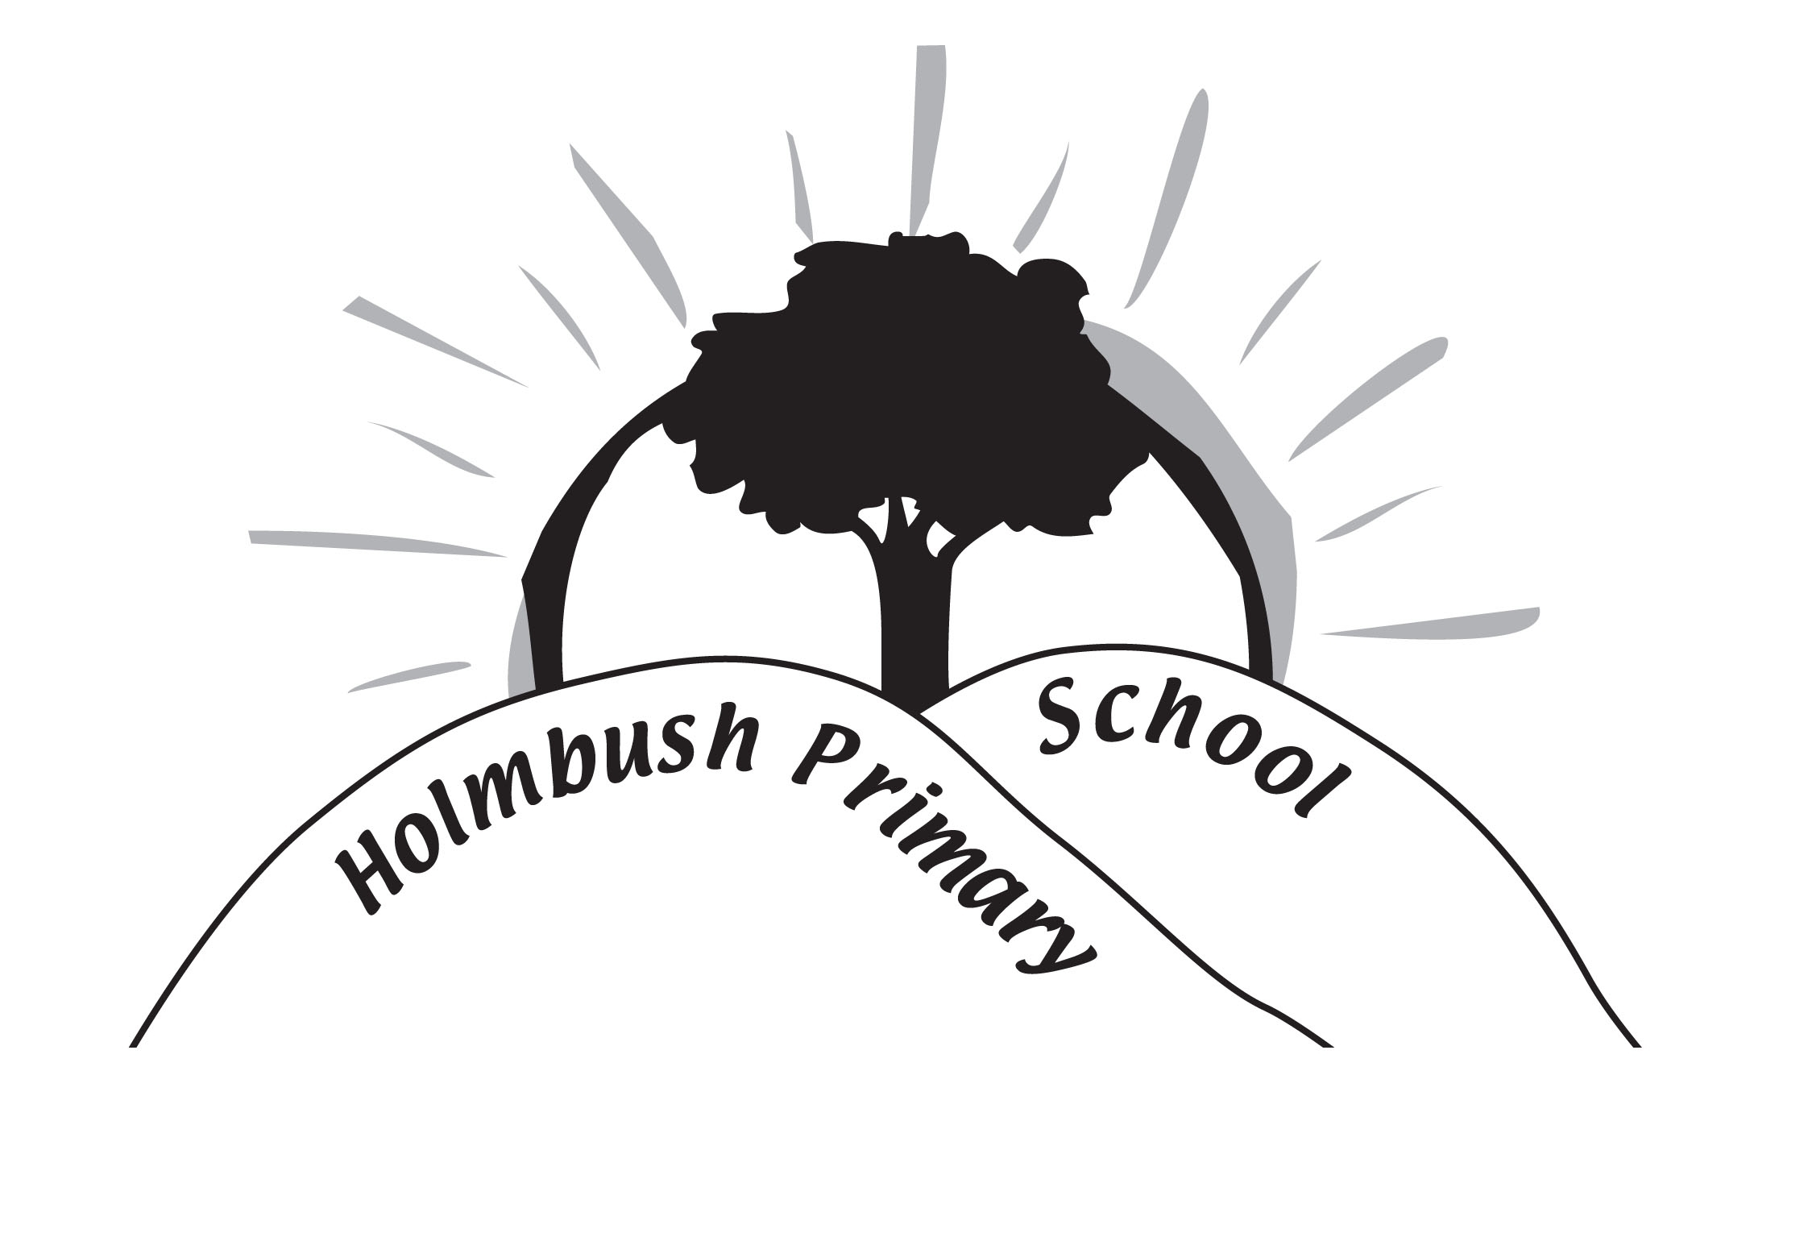

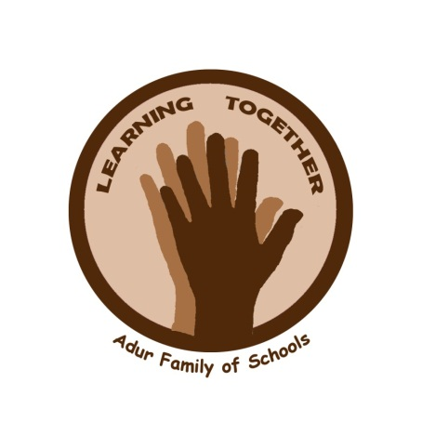

HOLMBUSH PRIMARY SCHOOL

Encouraging Good Behaviour and Safety Policy

Statement of Intent
The Governors and Staff at Holmbush Primary School are committed to providing a warm, caring and safe environment for all our children so that they can learn and play in a relaxed and secure environment.

Aims and Objectives of this Policy
This policy clearly defines the school’s stance in relation to Behaviour and Bullying. It provides a framework that enables all staff to take a fair and consistent approach when dealing with Behaviour and instances of bullying.

The aim of this policy is to try and prevent and deal with any negative behaviour or that deemed as bullying. The implementation of this policy will create an ethos where bullying is regarded as unacceptable so that a safe and secure environment is created for everyone to learn and work in. All members of the school have a responsibility to recognise bullying when it occurs and take appropriate action in accordance with the
school policy.

Values
As part of the Adur Family of Schools we share Spiritual, Moral, Social and Cultural values. These are on display in every classroom and around the school. (See Appendix One)

Children, good behaviour and learning
We are particularly concerned with good behaviour and providing good role models for the children. We think young children learn best when they are clear about what they are supposed to do and when they are continually and consistently encouraged to do it.

Children, teachers and parents have worked together to produce this policy. It sets out;
- what we think are the benefits of good behaviour
- what we mean by good behaviour
- how we encourage good behaviour
- how we discourage inappropriate behaviour

We want to help the children to;
- grow socially
- grow personally
- grow academically

The benefits of good social behaviour
At Holmbush Primary School we believe that because staff, children and parents value good social behaviour;

Children
- learn what good behaviour means
- develop self control
- learn to care for one another
- learn the value of friendship
- develop self-confidence
- do as well as possible in their learning and make good progress

Teachers
- teach effectively with fewer behaviour problems
- meet the needs of all children
- make positive contacts with parents

Parents
- feel confident that their children are growing personally, socially and academically
- know that the school will work with them to ensure their children receive support when they need it
- feel welcome in school to discuss their children’s progress in a positive atmosphere

What we mean by showing good behaviours
After discussion with parents, teachers and children we have agreed that good behaviour will be encouraged through the ‘Rights Respecting’ approach linked to our school value ‘Respect’. We encourage good behaviour by referring to every child’s ‘rights’ using the Convention of the Rights of a Child. We concentrate in particular on:

The right to be included.
The right to play.
The right to learn.

At the beginning of each school year each class will develop its own Class Charter based on these rights. Every member of the class will sign a class charter agreeing to the class rules. This is linked to our work as a Rights Respecting School and we have selected the vocabulary that we use so it is consistent across the school.

Good behaviour is encouraged in every area of school activity and children are helped to recognise examples of good behaviour at all times.

If, however, any child finds these general aims difficult the school will work with the parents/carers to help the child understand.

How we encourage good behaviour
Everyone at Holmbush Primary School has agreed to;
- recognise and highlight good behaviour as it occurs
- ensure that children are praised for behaving well
- ensure that criticism is constructive
- explain and demonstrate the behaviour we wish to see
- encourage children to be responsible for their own behaviour
- reward individual children and groups of children for behaving well.

We believe that good behaviour should be encouraged and recognised through praise and rewards.

Daily Praise
We value every child and aim that every child’s good behaviour will be recognised daily and be rewarded with praise. Praise can come from the child’s teacher or other adults in the school and also from other children. We nurture the children to recognise strengths and talents in each other and celebrate those through promoting peer praise and encouragement among all the children. As reflected in our school values.

Individual rewards and privileges may include;
- housepoints
- special responsibilities
- chosen to be a monthly Learning Hero or Values Champion
- good work shared with the Headteacher and rewarded with a leaf in assembly, children get to take a photo taken next to the achievement tree home

School Reward
The whole school is split into four houses. Children can gain Housepoints from all members of staff and these are totalled each week and recorded in house assemblies on a Friday. The house with the most points at the end of a week will be able to wear home clothes on the Monday.

For details of a rewards system see the reward pyramid in appendix 2.
Discouraging Inappropriate Behaviour
Every class uses a “Good to be Green” system. To encourage good behaviour every child starts each part of the day on “green”.
If a child behaves inappropriately they will be given a first warning and if the behaviour is repeated then an amber warning card.

Examples of amber offences
- calling out
- not listening to adults
- disrupting other children’s learning
- breaking a class rule
- talking during assembly
- running in the corridor

If the child has to be given a warning after being on amber then they will be sent to another member of staff and they will be given a red warning card. This should be for about 10-15 minutes depending on the age of the child.

Red offences will be sent to another member of staff in this order
- Another teacher
- Experienced teacher within your key stage
- Deputy Headteacher
- Headteacher

Examples of red offences
- any amber offence for the second time
Straight to red offences
- biting
- swearing (if heard by a member of staff, amber if reported)
- hurting someone else in any form, e.g. push, kick, punch, pinch etc
- lying to anyone
- speaking to any member of staff in a way they wouldn’t to another, this includes disrespect and arguing back
- leaving an area without permission

All offences will be recorded both on paper and on our e recording system. Amber offences will miss 5 minutes of the next playtime. Red offences will miss the whole of the next playtime, sitting under the gazebo on the active playground or staying with a teacher in the classroom. For most children this will ensure that they recognise the need to improve their behaviour. Each offence is issued with behaviour points. (See appendix 3 for our Behaviour pyramid)

Teachers keep weekly records of the Good to be Green system/behaviour points so we can help and support children who are consistently receiving ‘amber’ and ‘red’ warnings. These are monitored by our Inclusion Manager so that as a school we can look at the cause and effects of behaviour and put in place strategies to reduce the amount of inappropriate behaviour.

Informing parents/carers
Class teacher to discuss with parent informally:
All red offences
Having Amber warnings more than once in one week

Patterns of poor behaviour will be reported to the Senior Management Team who may decide to meet with parents more formally and draw up a plan to support that child.

If a child is sent to the Headteacher she will investigate the incident and decide on any sanctions that need to be applied.

Children who receive a red warning card have the opportunity to have them transferred back to “amber” by quickly improving their behaviour through a session and the same for amber to green. Every session starts with all the children as green.

We believe it is important for all children to recognise that expectations throughout the school are the same and any sanctions used are consistent. With this in mind and following feedback from the children any child with more than 10 behaviour points in a term will be unable to take part in any winning house treats.

All children have strengths and areas for development. Children who find reading difficult receive extra support with reading and the same is true for behaviour. Children who find achieving good behaviour particularly difficult may be given extra support and an Individual Behaviour Plan (IBP). This will be discussed with the parent.

Exclusion
In very rare cases it may be necessary to exclude a pupil, for example if there has been a serious attack on another person or if a child is a danger to themselves or others, for example leaving the school site or classroom. This will only ever be considered after all possible avenues have been explored. Only the Headteacher can exclude a child. Very careful arrangements will be made to ensure that any child returning to school after exclusion is helped to behave appropriately.

Break Times
At break times children are always supervised by adults. They are encouraged to play together amicably. However, if children experience difficulties in the playground they should inform the staff on duty. We encourage positive play by setting up activities and children act as play leaders.

Children are not permitted to be physically violent and disputes are settled by discussion. The school uses the ‘Restorative Chat’ to encourage children to take responsibility for their feelings and actions. It is not about accusing others during conflicts and problems. Anger and negative feelings are not directed at someone else. It is a problem solving skill.

Restorative Chat
We will always refer to every child’s rights when discussing their behaviour with them and as part of this work we use Restorative Chat. This is a consistent way of speaking with the children about their behaviour.

What happened?
What were you thinking?
What needs to happen to put things right?
What are you going to do differently next time?

It may be that a Restorative Circle needs to take place, particularly if there has been bullying.
Restorative Circle Script:
What happened?
What were you thinking?
What do you think now?
Who has been affected and how?
What needs to happen to put things right?
What do you need from the Circle?

If a contract is formed:
What do you need on the contract?
What might they need on the contract?

Bullying
Bullying of any kind is unacceptable and will not be tolerated in our school. We take all incidents of bullying seriously. Bullying hurts. No-one deserves to be a victim of bullying. Everybody has the right to be treated with respect and children who are bullying others need to learn different ways of behaving.

We are of the firm belief that, although children are generally kind and considerate to each other, there is a need to be constantly vigilant to eliminate any instances of behaviour that is upsetting or otherwise stressful to the recipient. When bullying does occur, children should feel able to talk about it and know that incidents will be dealt with promptly and effectively. This also includes anyone who knows that bullying is happening and should feel able to tell a member of staff.

Whole school initiatives (staff training, celebration assemblies etc) and proactive teaching strategies (PSHE [Personal, Social & Health Education] lessons, circle time etc) will be used throughout the school to reduce the opportunities for bullying to occur.

Definition
Bullying is defined as behaviour which, either intentionally or unintentionally, upsets or intimidates another child or children.

Bullying can be:
• Emotional - being unfriendly, excluding, tormenting (e.g. hiding books, threatening gestures), ridicule, humiliation
• Verbal - name-calling, sarcasm, spreading rumors, threats, teasing, making rude remarks, making fun of someone
• Physical - pushing, kicking, hitting, pinching, throwing stones, biting, spitting, punching or any other forms of violence, taking or hiding someone’s things
• Racist - racial taunts, graffiti, gestures, making fun of culture and religion
• Sexual - unwanted physical contact or sexually abusive or sexist comments
• Homophobic - because of/or focusing on the issue of sexuality
• Online/cyber - setting up ‘hate websites’, sending offensive text messages, emails and abusing the victims via their mobile phones
• Any unfavourable or negative comments, gestures or actions made to someone relating to their disability or special educational needs.

It is important to understand that bullying is not the odd occasion of falling out with friends, name calling, arguments or when the occasional trick or joke is played on someone. It is bullying if it is done several times on purpose. It is important that children learn that one person’s good nature teasing may, to another person, be unkind and even cruel. Children are taught, through PSHE to recognise the difference between teasing and bullying. They are also taught to understand that what is meant as good natured teasing may not always be received in the same way and that bullying may be unintentional.

Children sometimes fall out or say things because they are upset. When occasional problems of this kind arise it is not classed as bullying. It is an important part of children’s development to learn how to deal with friendship breakdowns, the odd name calling or childish prank. We all have to learn how to deal with these situations and develop social skills to repair relationships.

Where does bullying happen?
It can happen anywhere – in the classroom, in the corridor, in the toilets, in the dining hall, in the playground. Bullying may also happen on the way to and from school. In such cases, the Headteacher is empowered by law to deal with such incidents but must do so in accordance with the school’s policy.

At Holmbush Primary School, we are concerned with our children’s conduct and welfare outside as well as inside school and we will do what we can to address any bullying issues that occur off the school premises.

The following steps may be taken:
• Talk to the local Community Police Officer about problems on the streets
• Talk to the Head Teachers of other schools whose children may be involved in bullying off the premises
• Map out safe routes to school for children, linking them to the School Travel Plan
• Discuss coping strategies with parents
• Talk to the children about how to handle or avoid bullying outside the school premises

Signs and Symptoms
A child may indicate, by different signs or behaviour, that he or she is being bullied.
Adults should be aware of these possible signs and investigate further if a child:
• is frightened of walking to or from school
• begs to be driven to school
• changes their usual routine/route to school
• begins truanting
• becomes withdrawn, anxious or lacking in confidence
• starts stammering
• attempts or threatens suicide or runs away
• cries themselves to sleep at night or has nightmares
• feels ill in the morning
• begins to under perform in school work
• comes home with clothes torn or books damaged
• has possessions go "missing"
• asks for money or starts stealing money (to pay the bully)
• has unexplained cuts or bruises
• comes home starving (money/snack/sandwiches have been stolen)
• becomes aggressive, disruptive or unreasonable
• starts swearing or using aggressive language for no apparent reason
• is bullying other children or siblings
• stops eating
• is frightened to say what's wrong
• gives improbable excuses for any of the above

These signs and behaviours could indicate other problems, but bullying should be
considered a possibility and should be taken seriously and investigated as soon as
possible.

What can children do if they are being bullied?
Wherever children are in school, they have the right to feel safe. If someone is being bullied, it is important they know there are people who can help them.

Some of the strategies that can be used are listed below:
• Try not to let the bully know that he/she is making them feel upset.
• Try to ignore them.
• Be assertive - stand up to them, look at them directly in the eye, tell them to stop and mean it.
• Stay in a group, bullies usually pick on individuals.
• Get away as quickly as they can.
• Tell someone they can trust – it can be a teacher, a teaching assistant, a midday
supervisor, a parent, a friend, a brother, a sister or a relative.
• If they are scared, ask a friend to go with them when they tell someone.
• If they don’t feel they can talk to someone about it, write it down and pass it to the school office.
• When they tell an adult about the bullying give them as many facts as they can (What? Who? Where? When? Why? How?).
• Keep a diary of what’s been happening and refer to it when they tell someone.
• Keep on speaking out until someone listens and helps them.
• Never be afraid to do something about it and quick.
• Don’t suffer in silence.
• Don’t blame themselves for what is happening.
• Call a helpline.

What can children do if they see someone else being bullied?
Ignoring bullying is cowardly and unfair to the victim. Staying silent means the bully has won and gives them more power. There are ways children can help without putting themselves in danger.

Again, some strategies that can be used are listed below:
• Don’t smile or laugh at the situation.
• Don’t rush over and take the bully on themselves.
• Don’t be made to join in.
• If safe to do so, encourage the bully to stop bullying.
• If they can, let the bully know they do not like his or her behaviour.
• Shout for help.
• Let the victim(s) know that they are going to get help.
• Tell a member of staff as soon as they can.
• Try and befriend the person being bullied.
• Encourage the person to talk to someone and get help.
• Ask someone they trust about what to do.
• If they don’t feel they can talk to someone about it, write it down and pass it to the school office.
• Call a helpline for some advice.

Bullying of children with Special Educational Needs
Holmbush Primary School is an inclusive school. We provide a secure, accepting, safe and stimulating environment where everyone is valued for who they are. Everyone involved in the school is very aware that children who have learning disabilities and /or communication difficulties can be especially vulnerable to bullying and we are therefore particularly vigilant at all times.

High attainers, gifted or talented children can also be affected by bullying. Staff will treat this type of bullying as seriously and in the same way as any other type of bullying.

Procedures for reporting and responding to bullying incidents
All staff will respond calmly and consistently to all allegations and incidents of bullying at Holmbush Primary School. They will be taken seriously by all staff and dealt with impartially and promptly. All those involved will have the opportunity to be heard. Staff will protect and support all children involved whilst allegations and incidents are investigated and resolved.

The following step-by-step procedure will be used for reporting and responding to bullying allegations or incidents:
1. Report all bullying allegations and incidents to staff.
2. Staff will make sure the victim(s) is and feels safe.
3. Appropriate advice will be given to help the victim(s).
4. Staff will listen and speak to all children involved about the incident separately.
5. The problem will be identified and possible solutions suggested through a Restorative Circle.
6. Staff will attempt to adopt a problem solving approach which will move children on from them having to justify their behaviour.
7. Appropriate action will be taken quickly to end the bullying behaviour or threats of bullying.
8. Staff will reinforce to the bully that their behaviour is unacceptable.
9. The bully (bullies) may be asked to genuinely apologise. Other consequences may take place and appropriate sanctions applied (see below).
10. If possible, the children will be reconciled.
11. An attempt will be made, and support given, to help the bully (bullies) understand and change his/her/their behaviour.
12. In cases of serious bullying, the incidents will be recorded by staff on the standard Incident Report Sheet. All reports will be kept in a file in the school office.
13. In all cases parents will be informed and will be invited to come into school for a meeting to discuss the problem. This is parents of both the victim and the bully.
14. After the incident has been investigated and dealt with, each case will be monitored to ensure repeated bullying does not take place.
15. Bullying incidents will be discussed regularly at staff meetings.
16. The Headteacher will present termly reports on serious bullying incidents to the Governors through the Headteachers report.
17. If necessary and appropriate, the Child Protection Officer in school, Social Services or police will be consulted.

The following sanctions may be used:
Some of the sanctions that could be used are listed below:
• Apologise to the victim(s) verbally or in writing
• Lose privileges / golden time
• Lose playtimes
• Spend time with the Headteacher
• Spend playtimes and lunchtimes with an adult
• Parents will be invited in to school
• Reward chart / Report card
• Be removed from class and work in isolation
• Report to the Headteacher or Deputy Headteacher
• Fixed term exclusion
• Permanent exclusion

Strategies for the prevention and reduction of bullying
Whole school initiatives and proactive teaching strategies will be used throughout the school to develop a positive learning environment with the aim of reducing the opportunities for bullying to occur.

These can include:
• Involving the whole school community in writing and reviewing the policy
• Undertaking regular questionnaires and surveys to monitor the extent of bullying in the school and the effectiveness of the anti-bullying policy
• Producing a ‘child speak’ version of the policy for the children
• Each class agreeing on their own set of class rules / class charter
• Making national anti-bullying week / friendship week high profile events each year
• Awareness raising through regular anti-bullying assemblies
• PHSE (Personal, Health & Social Education) scheme of work and SEAL from Reception to Year 6 used to support this policy
• Circle time on bullying issues
• Setting up of a circle of friends support network where a small group of children volunteer to help and support an individual experiencing difficulties
• Children writing stories and poems and drawing pictures about bullying
• Children being read stories about bullying
• Using drama activities and role-plays to help children be more assertive and teach them strategies to help them deal with bullying situations
• Creation of a SEAL display and promoting ‘getting on’
• Prominently displaying anti-bullying and ‘how to be a good friend’ posters produced by the children around school
• Suggestion box where children and parents/guardians can write and post their concerns and ideas
• Introducing playground improvements and initiatives
• Training Y4 children to be Play Leaders
• Implementation of the Positive Play Programme
• Using praise and rewards to reinforce good behaviour
• Encouraging the whole school community to model appropriate behaviour towards one another
• Organising regular anti-bullying training for all staff

Monitoring and evaluation of the policy
Incidents of bullying at the school will be monitored by the Headteacher to identify any patterns i.e.
- Recurring complaints of bullying against a particular pupil or group of children
- Evidence that a particular child is, for some reason, becoming a target for bullies
- Particular times of the school day/week when bullying is tending to occur
- Particular situations where bullying may be occurring

In the event that a pattern appears to be forming, Class teachers will work to address the problem, both with the individuals concerned and more widely through PSHE teaching and other measures as appropriate, including involving parents.

We hope that you have found this booklet helpful. It summarises a great deal of thinking and discussion. We hope it conveys our positive views about behaviour in school.
In our view the importance of good behaviour cannot be over emphasised. Parents, staff and children all enjoy the happy social community at Holmbush Primary School and wish to maintain this through the help of all involved.

Monitoring and Review
The behaviour and safety of children at the school, and the effectiveness of this policy will be monitored on a termly basis. Findings will be reported to the Governing Body in the Headteacher’s Report to Governors each term.

Ofsted grade descriptor (Outstanding)  What | Monitoring and evaluation
Ofsted grade descriptor (Outstanding)  What | How | When | Who*
Views:  Parents, carers, staff and children are highly positive about behaviour and safety. | ParentView – Online Ofsted questionnaire | Termly | Head
 | School Council | Termly | Deputy
 | Governor monitoring visit and discussion with children. | Autumn | Gov
 | Annual questionnaire to parents and carers | Spring | SLT
 | School report feedback from parents | Spring | SLT
 | Eco Council (environment) | Annually | SLT
Responsibility:  Children make an exceptional contribution to a safe, positive learning environment. They make every effort to ensure that others learn and thrive in an atmosphere of respect and dignity. Children show very high levels of engagement, courtesy, collaboration and cooperation in and out of lessons. They have excellent, enthusiastic attitudes to learning, enabling lessons to proceed without interruption. | Lesson observations | Termly | Head/ Deputy
 | Staff Feedback
 | Feedback from visitors
 | Feedback from supply teachers
 | School Council
Punctuality:  Children are consistently punctual in arriving at school and lessons. | Half Termly review of attendance registers. | Half Termly | Admin / EWO
 | Monitoring at end of break/lunch | Termly | SLT
Self-control:  They are highly adept at managing their own behaviour in the classroom and in social situations, supported by systematic, consistently applied approaches to behaviour management. They are very calm, orderly and considerate when moving around the school. | Review of children with challenging behaviour | Half Termly | Inclusion Manager
 | Visitor feedback
 | Governor monitoring visit
 | Lesson observations
 | Review of pupil records and logs | Termly | Head
Improvements:  There are excellent improvements in behaviour over time for any individuals or groups with particular behavioural difficulties. | Review of children with challenging behaviour | Half Termly | Inclusion Manager
 | Review of PP files, incident/behaviour logs | Termly | Head
 | Case studies | Annually | SLT
Bullying:  Instances of bullying, including for example, cyber-bullying and prejudice-based bullying related to special educational need, sexual orientation, sex, race, religion and belief, gender reassignment or disability, are extremely rare. Children are acutely aware of different forms of bullying and actively try to prevent it from occurring. The school has an active and highly effective approach to identifying and tackling bullying. | Review Anti-Bullying Policy | Annually | Head
Being Safe:  All groups of children feel safe at school at all times. They understand very clearly what constitutes unsafe situations and are highly aware of how to keep themselves and others safe. | Pupil interviews | Annually | Gov
 | School Council
Attendance:  It is likely that attendance will be above average for all groups of children or will show sustained and convincing improvement over time. | Review of registers | Termly | EWO

